# **12.4 Guided Exercise: Backup Windows 10**

|  |  |
| --- | --- |
| **Resources** | |
| Files | None |
| Machines | Windows 10 |

In this exercise you will create a full backup of the Windows 10 machine.

Click on the Start Button and then click Settings.

Once the Settings window opens click on Update & Security button.

Then select Backup from the menu on the left and click on “Go to Backup and Restore (Windows 7)”

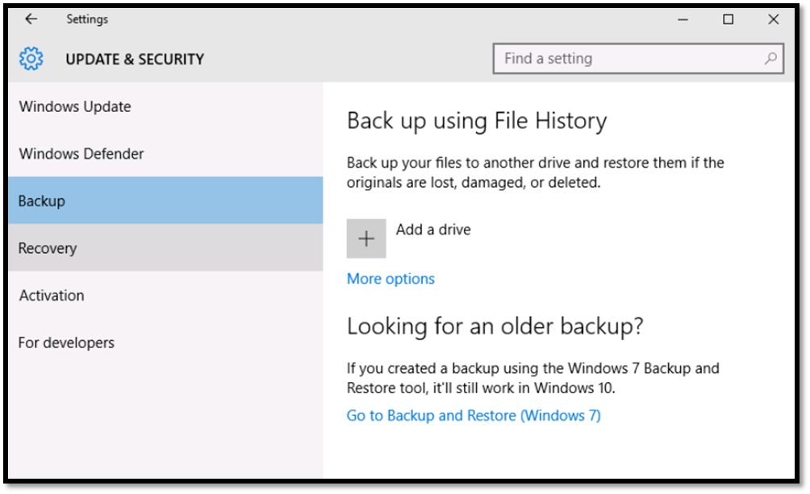

On the Backup and Restore (Windows 7) window click on Create a system image.

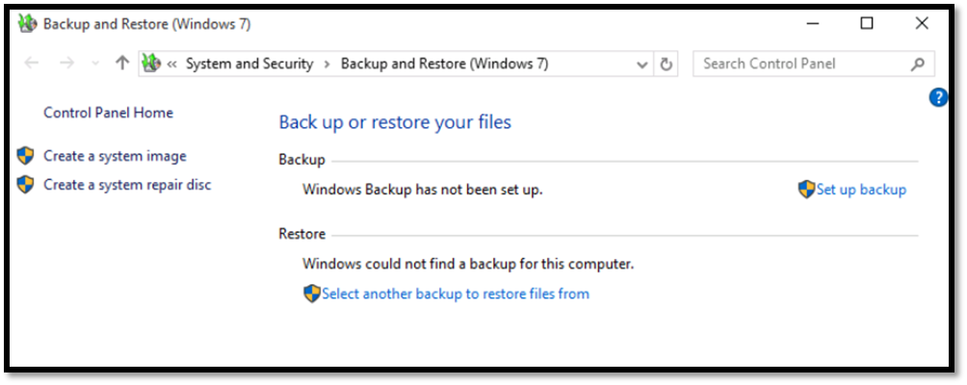

On the Create a system image window select the first option “On a hard disk” and ensure the Backup (E:) drive is selected. Then click Next.

On the Create a system image window select the first option “On a hard disk” and ensure the Backup (E:) drive is selected. Then click Next.

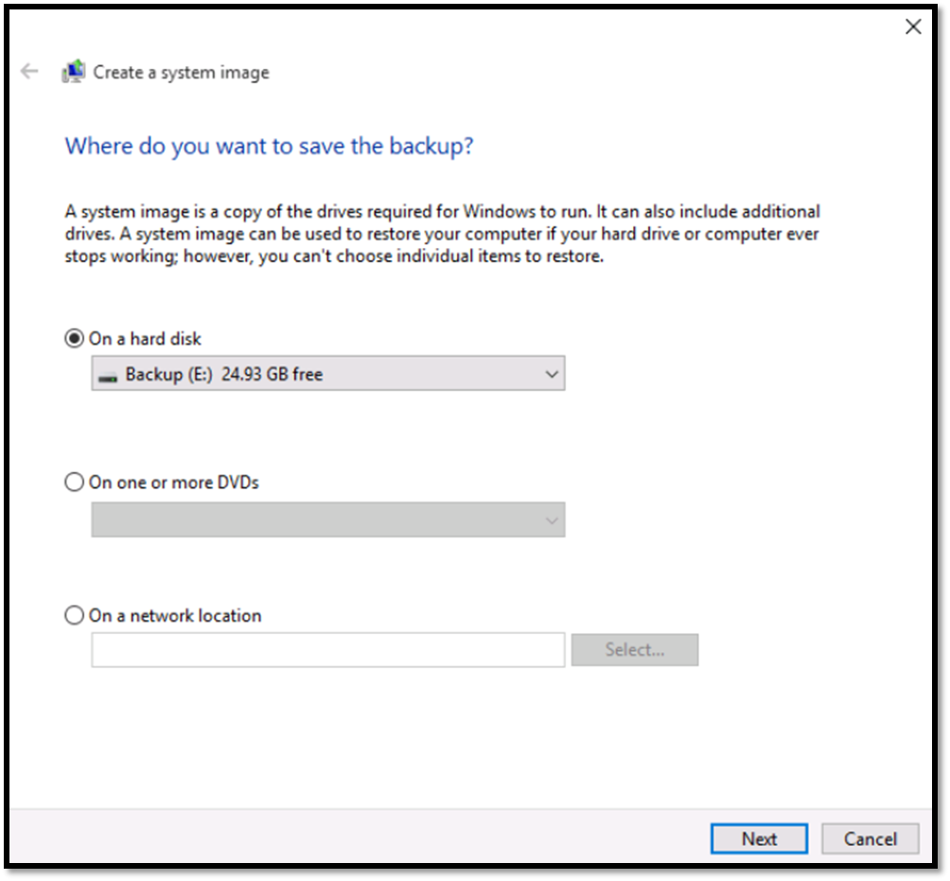

In the next window you can observe which drives will be backed up. In this case it should be “System Reserved (System)” and “(C) (System)”. Click Start backup.

On the window you will observe the backup progress.

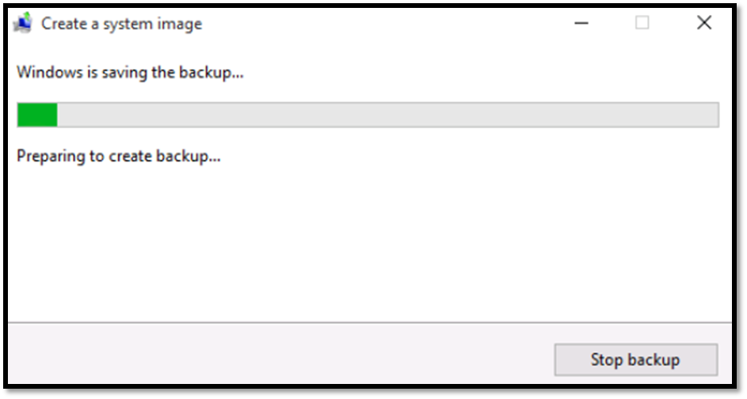  
Once the backup process will end it will ask you to create a system repair disk.  At this time click No, and then Close.

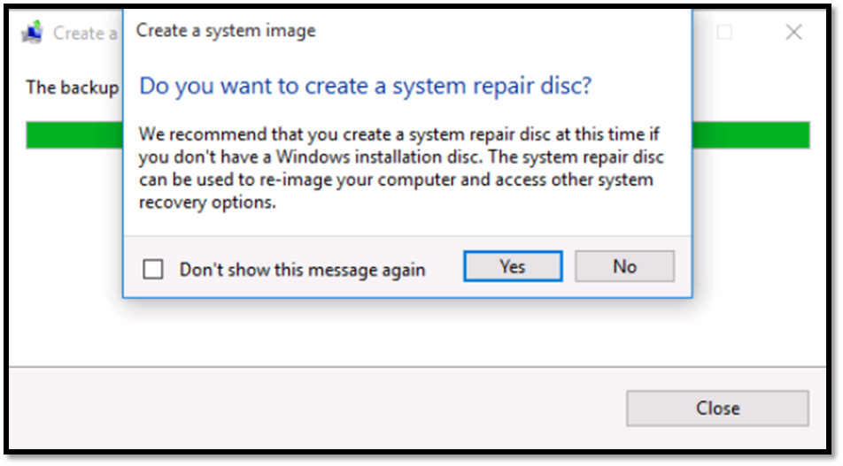

Open File Explorer and then click on “This PC”. You will observe that the drive “Backup (E)”  has 13 GB free from 25GB.

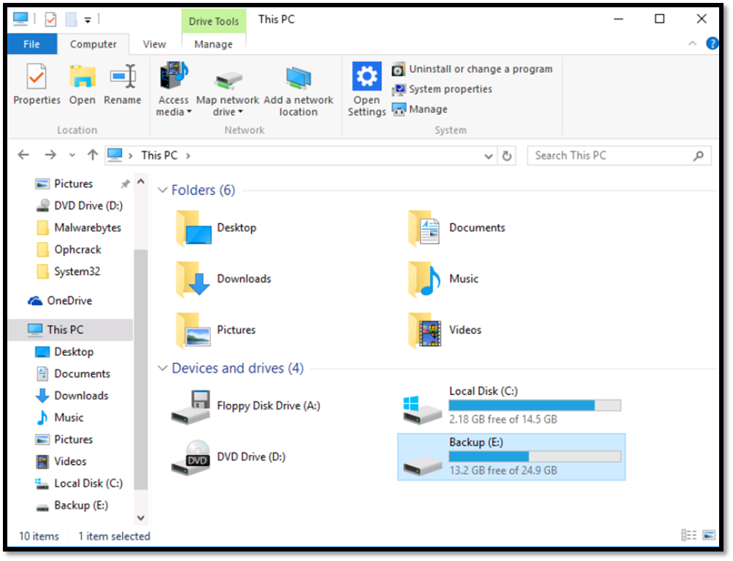

Open the drive “Backup (E)” and you will notice that a folder exists called “WindowsImageBackup” which contains the backup files.

